Godišnjak za sociologiju Vol. XX, No X, 20XX, xx–xx

UDK XXX.XXX.XXXX

Research Article
https://doi.org/.....

Title (Times New Roman, 12 Pt, Bold, Center Text, All Significant Words Are Capitalized)∗

Author 1 First and Last names^{1**} Author 2 First and Last names^{2***}, etc. (Times New Roman, 11 pt., centered)
¹Department, Faculty, University,Country
²Department, Faculty, University,Country
Etc. (Times New Roman, 11 pt., centered)

Abstract

Max 250 words; Text of the summary, Text of the summary, Text of the summary, Text of the summary, Text of the summary, Text of the summary. (Times New Roman, 10 pt, Justify, single line spacing).
Keywords: keyword 1, keyword 2 to (max) keyword 5 (Times New Roman, 10 pt, Justify, first line indent 0.5 in/1.27 cm, single line spacing)

Title of the Paper (Times New Roman, 12 Pt, Bold, Center Text, All Significant Words Are Capitalized)

The paragraphs continue from here and are only separated by headings. (Times New Roman 11 pt, Justify; first line indent 0.5 in/1.27 cm, single line spacing, Format B5).

Structure (Times New Roman, Bold, 11 pt; Left alignment)

Sample of main text. Sample of main text. Sample of main text. Sample of main text. Sample of main text. Sample of main text. Sample of main text. Sample of main text. Sample of main text. Sample of main text. Sample of main text. Sample of main text. Sample of main text. Sample of main text. Sample of main text. Sample of main text. Sample of main text. Sample of main text. Sample of main text. Sample of main text. Sample of main text. Sample of main text. Sample of main text. Sample of main text. (Times New Roman, 11 pt; paragraph format: justified alignment, first line indent 0.5 in/1.27 cm, single line spacing).

Structure (Times New Roman, Bold, 11 pt; Left alignment)

Sample of main text. Sample of main text. Sample of main text. Sample of main text. Sample of main text. Sample of main text. Sample of main text. (Times New Roman, 11 pt; paragraph format: justified alignment, first line indent 0.5 in/1.27 cm, single line spacing).

Method (Times New Roman, Bold, 12 pt, Center text)

Sample and procedure (Times New Roman, Bold, 11 pt; Left alignment)

Sample of main text. Sample of main text. Sample of main text. (Times New Roman, 11 pt; paragraph format: justified alignment, first line indent 0.5 in/1.27 cm, single line spacing).

Measures (Times New Roman, Bold, 11 pt; Left alignment)

Sample of main text. Sample of main text. Sample of main text. (Times New Roman, 11 pt; paragraph format: justified alignment, first line indent 0.5 in/1.27 cm, single line spacing).

…

Results (Times New Roman, Bold, 12 pt, Center text)

Sample of main text. Sample of main text. Sample of main text. (Times New Roman, 11 pt; paragraph format: justified alignment, first line indent 0.5 in/1.27 cm,, single line spacing).

All tables should be numbered with Arabic numbers (1,2,3...). Below the number of tables, there is the title (Times New Roman, 11 pt, Italic), with alignment. Only horizontal lines should be used within a table, to distinguish the column headings from the body of the table, and immediately above and below the table. The data font in the table is Times New Roman, 10pt, line spacing Single, where statistics are shown in Italic style. Tables must be embedded into the text and not supplied separately. Below is an example which the authors may find useful.

Table 1

Title

Column heading Column Column
A | heading | heading
 | 10 | 15
B | 20 | 25
C | 30 | 35

Figure 1

Figure title

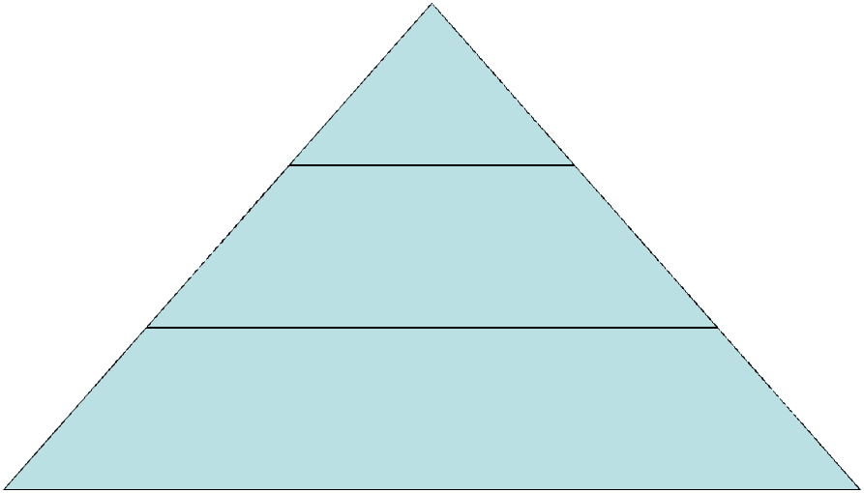

Discussion (Times New Roman, Bold, 12 pt, Center text)

Sample of main text. Sample of main text. Sample of main text. (Times New Roman, 11 pt; paragraph format: justified alignment, first line indent 0.5 in/1.27 cm, single line spacing).

Conclusion (Times New Roman, Bold, 12 pt, Center text)

Sample of main text. Sample of main text. Sample of main text. (Times New Roman, 11 pt; paragraph format: justified alignment, first line indent 0.5 in/1.27 cm, single line spacing).

References (Times New Roman, Bold, 12 pt, Center text)

Use APA7 style guidelines

Text formatting in reference list: Times New Roman, 11 pt., Line spacing: single; Paragraph alignment: Justify, Paragraph Indentation: Hanging, indent of 0.5 in/1.27cm (meaning that the first line of the reference is flush left and subsequent lines are indented 0.5 in. from the left margin.).
http://www.apastyle.org/
add DOI number where it is possible in format: https://doi.org/xxxxxxxxxxxxxxxx

Instruction and examples of citing in reference list:

Books (monographs) are cited in the following manner:

Palmore, E. (1999). Ageism: Negative and positive. Springer

Stojiljković, S. (1998). Ličnost i moral.,Institut za pedagoška istraživanja.

Chapters in a book or proceedings are cited in the following manner:

Widiger, T. A. (2005). Classification and diagnosis: Historical development and contemporary issues. In J. E. Maddux & B. A. Winstead (Eds.), Psychopathology: Foundations for a contemporary understanding (pp. 63-83). Erlbaum.

Journal articles are cited in the following manner:

Tracy, J. L., & Robins, R. W. (2004). Putting the self into self-conscious emotions: A theoretical model. Psychological Inquiry, 15(2), 103-125. https://doi.org/10.1207/s15327965pli1502_01

In-text example: (Tracy & Robins, 2004)

Webpage on a website - Author Surname, Initial(s) or Organisation Name. (year). Title of webpage. Site Name. URL

In text (Author, year)

If there is no information about the year then in parentheses should be given abbreviation n.d.

Brown, L. S. (2018). Feminist therapy (2nd ed.). American Psychological Association. https://doi.org/10.1037/0000092-000
Caena, F. (2011). Literature review Quality in Teachers’ continuing professional development. Education and training, 2020. Thematic Working Group ‘Professional Development of Teachers’. European Commission.
http://ec.europa.eu/dgs/education_culture/repository/education/policy/strategic-framework/doc/teacher-competences_en.pdf
Harris, L. (2014). Instructional leadership perceptions and practices of elementary school leaders [Unpublished doctoral dissertation]. University of Virginia.
McCauley, S. M., & Christiansen, M. H. (2019). Language learning as language use: A cross-linguistic model of childlanguage development. Psychological Review, 126(1), 1–51.https://doi.org/10.1037/rev0000126
Tracy, J. L., & Robins, R. W. (2004). Putting the self into self-conscious emotions: A theoretical model. Psychological Inquiry, 15(2), 103–125. https://doi.org/10.1207/s15327965pli1502_01
Yoo, J., Miyamoto, Y., Rigotti, A., & Ryff, C. (2016). Linking positive affect to blood lipids: A cultural perspective [Unpublished manuscript]. Department of Psychology, University of Wisconsin–Madison.
Widiger, T. A. (2005). Classification and Diagnosis: Historical Development and Contemporary Issues. In J. E. Maddux & B. A. Winstead (Eds.), Psychopathology: Foundations for a contemporary understanding (pp. 63–83). Lawrence Erlbaum Associates Publishers.

If one author is cited several times, it should be ordered by year of the reference publication, i.e. (if he has co-authors) by the surname of the first co-author. If several works of the same author are cited in one year, the years should be indicated in letters a, b, c; e.g. (1995a), (1995b).

Title In Serbian (Times New Roman, 12 Pt, Bold, Center Text)

Author 1 First and Last names¹Author 2 First and Last names², etc. (Times New Roman, 11 pt., centered)
¹Department, Faculty, University,Country
²Department, Faculty, University,Country
Etc. (Times New Roman, 11 pt., centered)

Abstract in Serbian (Bold)

Short abstract (max. 250 words). Abstract contains only the most important information (research goal, method, results and conclusions). Do not use references in the abstract (Times New Roman, 10 pt, Justify)
Keywords on Serbian (Italic): keyword 1, keyword 2… up to (max) key word 5 (Times New Roman, 10 pt, Justify)

RECEIVED: ____________
REVISION RECEIVED: ___________
ACCEPTED: _____________

e-mail authors

Corresponding author: Acknowledgement: The paper is a part of the research done within the project 1234567890. The authors would like to thank to the …… ∗Please cite as: **ORCID (author 1) *** ORCID (author 2)

